Predicting Housing Prices
  - Big Data INSY-5376
Molly Kelsey
Andreas Savva
Andy Goss
Kevin Hansen
May 3, 2017

Table of Contents
Introduction 3
Data Collection and Preprocessing 3
Model Evaluation and Results using Weka 5
Model Evaluation and Results Using PySpark 6
Sources 7
Zillow Estimate Model (1.0) 8
TAD Total Appraisal Value Model (1.1) 9
TAD Total Market Value Model (1.2) 10
Weka Model Example (1.3) 11
Zillow Estimate Amount By Observation (2.0) 11
Zillow Estimate Amount By Square Footage Of House (2.1) 12
Zillow Estimate Amount By Age (2.2) 12
Multilinear Regression MLLib Output (3.0) 13
Random Forest Regression MLLib Output (3.1) 13

Introduction
In March of each year home owners in Tarrant County receive in the mail a new property value estimate. This estimate is what the county has mysteriously calculated and will base the upcoming years taxes on. As home owners in Tarrant County we wondered how accurate these estimates are, especially since they have climbed significantly the last several years. The data analysis we are performing is an attempt to determine how accurate the Tarrant County Appraisal District estimates are. Armed with this data we are hoping to be able to determine if homeowners like ourselves should be able to determine if it makes sense to challenge the estimates.
For our project we are comparing housing data from Tarrant County Appraisal District and Zillow.com. The Tarrant County appraisal site lets you do a property search to get market value information. We scraped data, using beautiful soup, from the Tarrant County Appraisal District website to gather information on residential homes in Arlington Texas using the wildcard ‘%’ in the search field. We combined that data with the data from Zillow’s GetDeepSearchResults API call, using the address as the connecting key. We wanted to compare the value of a home on the Appraisal site and what it actually sold for on Zillow, also analyzing what type of home such as a mobile home, and comparing the number of bedrooms, bathrooms, and square feet per home. We combined the data into a JSON record and from there exported into a CSV file, then began our analysis. We have nine attributes which are as follows: Total Approximate Size, Total Appraisal Value, Address, Total Market Share, Number of Bedrooms, Number of Bathrooms, Amount, Valuation Range High, and Valuation Range Low. We had a total of 2,000 records.

Data Collection and Preprocessing
The primary data sources for this project were twofold: the Tarrant County Appraisal District website (http://www.tad.org/), and the Zillow API (https://www.zillow.com/howto/api/GetDeepSearchResults.htm).
On the Tarrant Country Appraisal District website, we used the built in Property Search feature to retrieve local commercial properties as paginated results. From each of these pages we attempted to use an online tool called import.io to scrape the information displayed in the main search results table, but we were unsuccessful due to how the page was being rendered. Each search results page produced by the TAD website was paginated, but it’s paginated value was not tracked via query string in the URL of the page. For this reason, it was not possible for import.io to scrap each page because each page did not have a uniquely identifying URL. To get around this issue, the table was selected manually via a mouse and keyboard, and was copied into an excel spreadsheet. Using this method we were able to capture the following properties: Account, Location, City, Owner Name, Use, and Market Value.

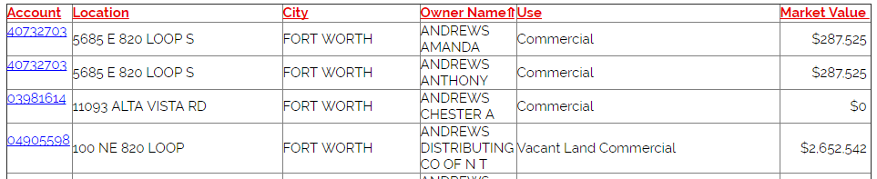

The excel file produced by this manual step was then converted into a csv file using excels Save As function. This comma delimited file was then imported using pythons built in IO functionality. Each record value was stripped of all special and white space characters that proceeded and ended the main string content. The account column was then targeted, and its number was used to retrieve a property detail page from the TAD website via an http request. These requests were of course throttled using a sleeper thread of two seconds as to avoid being blocked from the Tarrant Country Appraisal website administration. Using a third-party library called beautiful soup, the contents of each of these pages was then scraped for the following information:
- Property location, the address line of the property
- Land Market Value, the market value of the land on which the property stands
- Improved Market Value, the market value of the property
- Total Market Value, the sum of Land Market Value and Improved Market Value
- Land Appraisal Value, the appraisal value of the land on which the property stands
- Improved Appraisal Value, the appraisal value of the property
- Total Gross Building Area
- Total Net Leasable Area
- Total Land in Square footage
- Total Land in Acres
These read in values were then stripped, and voided of all special characters to produce alphanumeric strings. For numeric values that indicated a dollar amount, the comma and dollar sign were removed to produce a floating-point value. Any unknown values were replaced with a “NULL” string indicating that the value was not found on the TAD website.
To obtain housing data from the Zillow website we opted to use Zillow’s public accessible API. After doing a significant amount of research about the API’s RESTFUL interface we discovered that a wrapper already existed for the API as a python package called python-zillow. Using pip install we imported this API into our local python environment and leveraged its already made method calls to reduce our development efforts.
To obtain information from Zillow we made a series of request to the GetSearchResults method provided by the python-zillow package. This method required three parameters, the ZWSID, the address, and the zip code. The ZWSID acted as an identifying key; to obtain this key we signed up through Zillow to gain access to their API. The address and zip code were obtained from the TAD result set. The result of this request was an object that provided the ZPID which identified each individual house record. The ZPID was then later used to obtain Zillow estimate information for the property using the GetZestimate method. This method required a ZWSID, a ZPID, and a RentZestimate. The resulting object for each record was then converted into a dictionary and stored as a JSON string inside of text file delimited by a new line.
One of the challenges of using this API was the limit invoked by Zillow on the number of requests that could be made within a single day. With a data set that consisted of over 2,000 records the requests to Zillow would max out at about 400 records. To get around this issue we obtain additional keys for the Zillow API that were used to obtain more records. To keep track of the records that were already obtained, we utilized a text file to the store the address line for each record that was successfully retrieved from Zillow. This in effect provided us with two benefits: it eliminated the possibility of having duplicated records for the same address, and it eliminated redundant calls to the Zillow API.
After obtaining the entire data set over the course of several hours we discovered that the GetZestimate call to Zillow’s API was only returning a subset of the full JSON record we required for our analysis. For example, the bathrooms and bedrooms for each property had consistent values of null or none in place of a meaningful numeric value. After some investigating in Zillow’s documentation we discovered that a more robust request could be made that would give us a more accurate and complete result set for each property. This request was the GetDeepSearchResults request. Utilizing this request also had the added benefit of eliminating the additional request of getting search results and then later retrieving Zillow estimate data.
The result of these efforts was a complete JSON data set that included Tarrant county information and Zillow information combined to produce a complete picture of each property.
Naturally, several iterations of the development of this software were required to meet changing requirements. The first was to better manage the merge of the TAD site and Zillow datasets which were original kept separate. The second was for changing the Zillow API calls that were being made from a less inclusive dataset (GetSearchResults) call to a more inclusive one (GetDeepSearchResults).
Finally, the text file which contained all of our JSON documents was then parsed to produce a csv file that would then be used to perform a regression analysis. The values that were included in the CSV included the following:
- ID
- ZPID
- Address
- City
- Zip code
- Total Approximate Size
- Total Appraisal Value
- Total Market Share
- Zestimate Amount
- Valuation Range High
- Valuation Range Low
- Bedrooms
- Bathrooms
- Usecode
- Last Sold Date
- Year Built
- Complete
- Finished Square Feet

Model Evaluation and Results using Weka
After several failed attempts to use Pyspark and MLLib to generate a workable model, we resorted to using a third party application called WEKA. Before evaluating the information further, processing was required to cleanse the data set. We took the following steps:
- Narrowing the scope to Single Family properties.
- Eliminating all non-numeric values like addresses, id, city, etc.
- Eliminating any records with NULL values
- Converting the year built into an age of the home
- Eliminating a few outliers from the dataset (i.e. 135 sq ft properties worth 150k)
Once the data was cleansed, we processed the dataset in Weka using a Linear Regression algorithm. We ran the model using cross validation Folds of 10, 25, 50 and Percentage Split of 66% which had minimal impact on the model. Consequently, we used a cross-validation fold of 10 for the final models generated.
With Total Appraisal Value, Total Market Share and Zestimate, we generated three different models in order to see how close we could come to each value for a given property. The output of each of these models can be seen in the index under sections 1.0, 1.1, and 1.2
We noticed differences in each model, particularly when estimating TAD data using WEKA to exclude bedrooms. This infers that bedrooms are less significant in the overall estimate of the home over square footage, bathrooms, and even the age of the property.
Fortunately, we had actual data we could use to test the models. We took a residence, which was not included in our original dataset and used our linear regression models to make a prediction. The property we chose was located in Arlington. It was 2,010 square feet, had 4 bedrooms, 2 baths and was 17 years old. The calculated value for the Zillow model was less than $3,000 from the actual Zestimate on the Zillow website. Therefore, Zillow uses many of the same variable we identified in this process to estimate home values. The calculated value for the TAD Market Value was off by approximately $16,000 from the actual TAD Market Value. Thus, the land square footage plays are large role in the TAD Market Value calculation and by including it in our model it helped improve our results. Finally, the calculated value for the TAD Total Appraisal Value was off by approximately $7,000 from the actual TAD Total Appraisal Value. The conclusion here is twofold. First, the amount a property can increase each year from an appraisal perspective is capped by the State of Texas. Second, as with the TAD market share value, land square footage has an impact on the ability to accurately estimate values.
Thus, homeowners owe it to themselves to scrutinize the appraisal values estimated by the Tarrant County Appraisal District. A simple review of Zillow data or other home estimates will help ensure that the annual increase is in line with the actual increase of the home itself. Given more time and resources, we could surely identify other factors which can help improve the actual estimate of a home’s value including schools, crime rate, and foreclosure rate just to name a few.

Model Evaluation and Results Using PySpark
Through much trial and error, we used PySpark to build predictive models for our dataset. Our first step was to use the generated csv file called final_data_set.csv to read in all our gathered information into a data frame using PySpark’s built in SQL context. The schema for this context was inferred from the columns provided. Next, we output some high-level statistics about our data set using the describe and to pandas functions. Some metrics worth noting were the Zillow estimate amount at $177,771.36 on average, and the total market value of $48,555.69 on average.
From the data frame, we then generated an RDD of Label Points using Zillow estimate amount at the label (y-variable) and the total approximate size, finished square footage, numbers of bedrooms, number of bathrooms, and age as the features (x-variables). The year built was computed from the year built column minus the current year (2017). In addition, only records that had a use code of Single Family were kept as part of the Label Point RDD. Finally, any record that had a none or null value for the label point and/or features was removed from the data set for analysis. Naturally this was not the best course of action especially when considering the size of the data set being analyzed. Future work for this project could entail attempting to create an estimated or predictive value for the values that were marked as null using a common clustering algorithm like k-means nearest neighbor. The final record count used for training and testing our models included 1,281 records.
One of our firsts tasks was to graph our target variable, Zillow estimate amount, in sorted order to accurately portray how diverse our data set was. Using a third-party library called matplotlib we collected all our label points in our RDD and graphed them using a line graph (see appendix 2.0). This showed a relatively standard distribution of housing values ranging from the 80,000 range to the 500,00 range. The majority of houses were within the $200,000 to $300,000 range.
We then proceeded to create a multi-linear regression model from this data set using the Regression Metric algorithm provided by the mllib pyspark library. We created a random 70/30 split of the dataset using 70% for training and 30% for testing. The total number of training records was 865 and the total number of testing records was 416. The linear regression model produced a 75.66% R-squared error and a root mean squared error of 31,719.18. The weighted total of the features suggested that a considerable amount of the variance in this data set could be explained by the total approximate size and the finished square footage of the property. This indicates that a strong linear relationship exists between these two metrics and the predicted value. As can be seen by graph in appendix 2.1, the square footage of the property and the Zillow estimate amount showed a very strong linear relationship when plotted. This is likely why the R-squared value is considerably high. However, the mean squared error was relatively higher than expected which suggest that this data set could use more depth and width in terms of records and attributes. Next we ran our data through the Random Forest Regression Model, output can be found in appendix 3.1. We used the Random Forest Regression Metric algorithm provided by the mllib pyspark library. We also used a random 70/30 split as shown in the multi-linear regression model. The Random Forest Regression model produced a test mean squared error of 9,444,227,497.397. This is rather high. The smaller the mean squared error the closer you are to finding the line of best fit, or the trend line. According to the Random Forest Algorithm are data must be scattered all over the place. In the future it may be best to run this algorithm again, but with only a few attributes selected.
When approaching the issue of predicting house values logically several important attributes were missing from this model including crime rate, residential income, tax records, proximity to schools, and school performance. Including these attributes would likely yield a much stronger model that could more accurately predicting the market value of household within any given zip code.

Sources

Zillow API : https://www.zillow.com/howto/api/PropertyDetailsAPIOverview.htm

TAD Data Source : http://www.tad.org/data/downloads

Python Code Source : https://github.com/seme0021/python-zillow

Zillow Estimate Model (1.0)

=== Run information ===

Scheme: weka.classifiers.functions.LinearRegression -S 0 -R 1.0E-8 -num-decimal-places 4
Relation: modified_data_set-weka.filters.unsupervised.attribute.Remove-R1-2,4-5
Instances: 1217
Attributes: 5
zestimate_amount
bedrooms
bathrooms
age
finished_sqft
Test mode: 10-fold cross-validation

=== Classifier model (full training set) ===

Linear Regression Model

zestimate_amount =

-11122.2238 * bedrooms +
15056.7276 * bathrooms +
-234.1785 * age +
92.6589 * finished_sqft +
24803.7082

Time taken to build model: 0.06 seconds

=== Cross-validation ===
=== Summary ===

Correlation coefficient 0.9053
Mean absolute error 20071.6468
Root mean squared error 28138.4642
Relative absolute error 39.1736 %
Root relative squared error 42.4339 %
Total Number of Instances 1217

TAD Total Appraisal Value Model (1.1)

=== Run information ===

Scheme: weka.classifiers.functions.LinearRegression -S 0 -R 1.0E-8 -num-decimal-places 4
Relation: modified_data_set-weka.filters.unsupervised.attribute.Remove-R2-5
Instances: 1217
Attributes: 5
total_appraisal_value
bedrooms
bathrooms
age
finished_sqft
Test mode: 10-fold cross-validation

=== Classifier model (full training set) ===

Linear Regression Model

total_appraisal_value =

6990.6717 * bathrooms +
-835.8657 * age +
74.0312 * finished_sqft +
33935.2237

Time taken to build model: 0 seconds

=== Cross-validation ===
=== Summary ===

Correlation coefficient 0.8607
Mean absolute error 24143.9072
Root mean squared error 32005.6031
Relative absolute error 45.8213 %
Root relative squared error 50.8577 %
Total Number of Instances 1217

TAD Total Market Value Model (1.2)

=== Run information ===

Scheme: weka.classifiers.functions.LinearRegression -S 0 -R 1.0E-8 -num-decimal-places 4
Relation: modified_data_set-weka.filters.unsupervised.attribute.Remove-R1,3-5
Instances: 1217
Attributes: 5
total_market_share
bedrooms
bathrooms
age
finished_sqft
Test mode: 10-fold cross-validation

=== Classifier model (full training set) ===

Linear Regression Model

total_market_share =

5637.1033 * bathrooms +
-621.953 * age +
81.4309 * finished_sqft +
26212.1613

Time taken to build model: 0 seconds

=== Cross-validation ===
=== Summary ===

Correlation coefficient 0.8657
Mean absolute error 23529.7497
Root mean squared error 32399.8487
Relative absolute error 43.6186 %
Root relative squared error 50.0064 %
Total Number of Instances 1217

Weka Model Example (1.3)

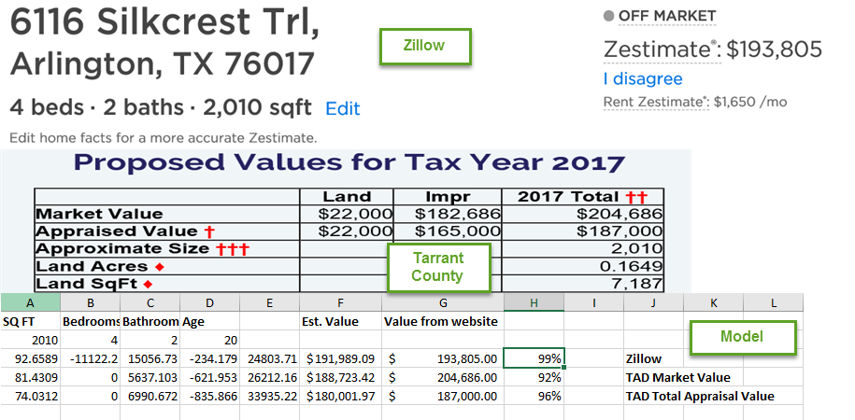

Zillow Estimate Amount By Observation (2.0)
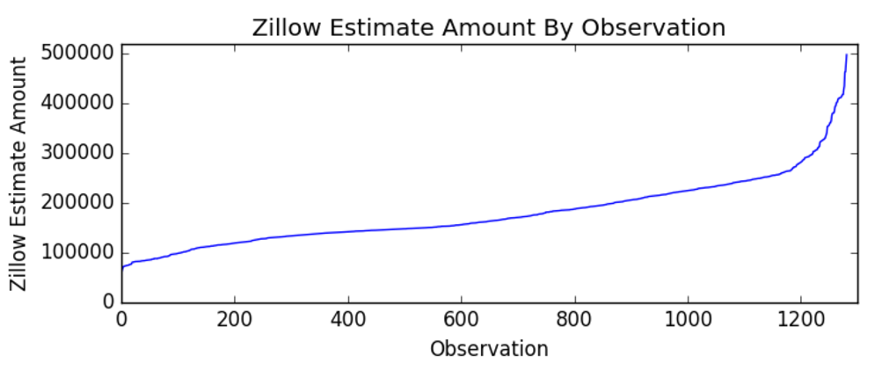

Zillow Estimate Amount By Square Footage Of House (2.1)
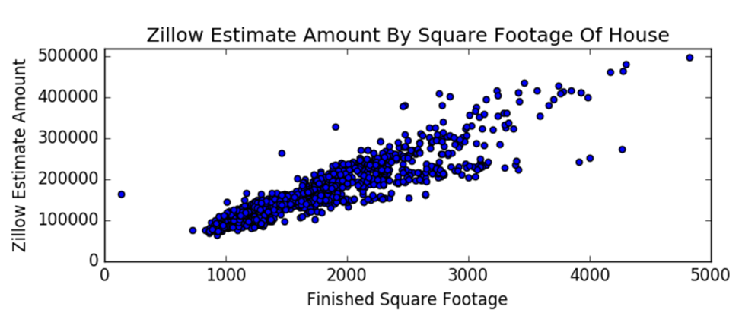

Zillow Estimate Amount By Age (2.2)
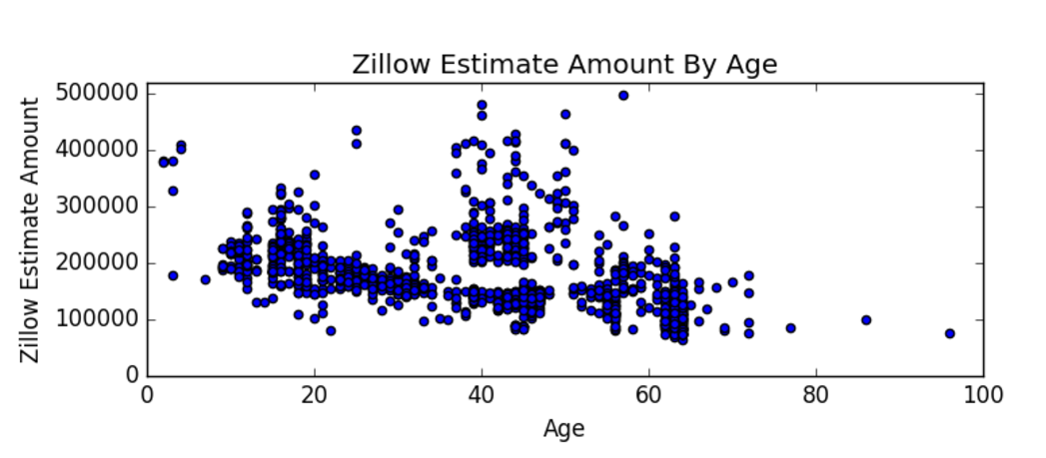

Multilinear Regression MLLib Output (3.0)
('Number of records', 1281)
('Training Data Set Count', '865')
('Testing Data Set Count', '416') (weights=[46.501184694,52.8851766448,0.0487071266617,0.0631115634343,-0.0253500327549], intercept=0.0)
('R-Squared', 0.7566022255093893)
('Mean Squared Error', 1006106637.1021352)
('Root Mean Squared Error', 31719.18405479774)
('Mean Absolute Error', 22011.509881244176)
('Explained Variance', 3781196007.9350147)

Random Forest Regression MLLib Output (3.1)
Test Mean Squared Error = 9444227497.397
If (feature 0 <= 2108.0)
If (feature 1 <= 1410.0)
If (feature 0 <= 1189.0)
If (feature 1 <= 980.0)
Predict: 84990.89655172414
Else (feature 1 > 980.0)
Predict: 109634.30120481928
Else (feature 0 > 1189.0)
If (feature 4 <= 62.0)
Predict: 135009.26315789475
Else (feature 4 > 62.0)
Predict: 108305.0
Else (feature 1 > 1410.0)
If (feature 1 <= 1740.0)
If (feature 4 <= 32.0)
Predict: 165878.7012987013
Else (feature 4 > 32.0)
Predict: 147001.6037735849
Else (feature 1 > 1740.0)
If (feature 4 <= 43.0)
Predict: 196501.09701492538
Else (feature 4 > 43.0)
Predict: 168911.88372093023
Else (feature 0 > 2108.0)
If (feature 0 <= 3146.0)
If (feature 3 <= 3.0)
If (feature 0 <= 2303.0)
Predict: 216324.2875
Else (feature 0 > 2303.0)
Predict: 254095.96268656716
Else (feature 3 > 3.0)
If (feature 4 <= 38.0)
Predict: 400171.6666666667
Else (feature 4 > 38.0)
Predict: 253403.0
Else (feature 0 > 3146.0)
If (feature 4 <= 19.0)
If (feature 2 <= 3.0)
Predict: 283352.5
Else (feature 2 > 3.0)
Predict: 238959.0
Else (feature 4 > 19.0)
If (feature 4 <= 40.0)
Predict: 423506.54545454547
Else (feature 4 > 40.0)
Predict: 381866.1
Tree 1:
If (feature 1 <= 1992.0)
If (feature 1 <= 1380.0)
If (feature 4 <= 61.0)
If (feature 0 <= 1189.0)
Predict: 111699.67441860466
Else (feature 0 > 1189.0)
Predict: 137018.80597014926
Else (feature 4 > 61.0)
If (feature 1 <= 980.0)
Predict: 85728.83333333333
Else (feature 1 > 980.0)
Predict: 104392.32835820895
Else (feature 1 > 1380.0)
If (feature 1 <= 1771.0)
If (feature 0 <= 1614.0)
Predict: 150282.5294117647
Else (feature 0 > 1614.0)
Predict: 163939.2641509434
Else (feature 1 > 1771.0)
If (feature 4 <= 44.0)
Predict: 190778.10447761195
Else (feature 4 > 44.0)
Predict: 167485.04347826086
Else (feature 1 > 1992.0)
If (feature 0 <= 3146.0)
If (feature 3 <= 3.0)
If (feature 0 <= 2238.0)
Predict: 211854.34939759035
Else (feature 0 > 2238.0)
Predict: 241390.35333333333
Else (feature 3 > 3.0)
If (feature 1 <= 2476.0)
Predict: 253403.0
Else (feature 1 > 2476.0)
Predict: 389254.3333333333
Else (feature 0 > 3146.0)
If (feature 4 <= 19.0)
If (feature 3 <= 3.5)
Predict: 244425.25
Else (feature 3 > 3.5)
Predict: 325826.0
Else (feature 4 > 19.0)
If (feature 2 <= 5.0)
Predict: 399005.92
Else (feature 2 > 5.0)
Predict: 285742.0
Tree 2:
If (feature 1 <= 1868.0)
If (feature 1 <= 1331.0)
If (feature 3 <= 1.0)
If (feature 0 <= 995.0)
Predict: 87917.66666666667
Else (feature 0 > 995.0)
Predict: 112843.25531914894
Else (feature 3 > 1.0)
If (feature 3 <= 2.0)
Predict: 115206.67857142857
Else (feature 3 > 2.0)
Predict: 165359.0
Else (feature 1 > 1331.0)
If (feature 4 <= 32.0)
If (feature 3 <= 2.0)
Predict: 170436.71186440677
Else (feature 3 > 2.0)
Predict: 174495.7142857143
Else (feature 4 > 32.0)
If (feature 1 <= 1696.0)
Predict: 141595.03867403316
Else (feature 1 > 1696.0)
Predict: 162743.62790697673
Else (feature 1 > 1868.0)
If (feature 3 <= 3.5)
If (feature 1 <= 2305.0)
If (feature 1 <= 1992.0)
Predict: 196179.75
Else (feature 1 > 1992.0)
Predict: 214816.52
Else (feature 1 > 2305.0)
If (feature 1 <= 3159.0)
Predict: 251370.7251908397
Else (feature 1 > 3159.0)
Predict: 337594.5833333333
Else (feature 3 > 3.5)
If (feature 2 <= 4.0)
Predict: 395099.0
Else (feature 2 > 4.0)
Predict: 414119.0

